Motorbikes Vs. Quads: Which Is Best?

If you are toying with the idea of buying a motorbike, as you like the idea of lots of raw power at your disposal, let’s not forget the quad. It’s a 4-wheeled vehicle that is as much fun as a bike, but you have 4 wheels on the ground instead of 2.

Let’s examine both forms of transport, looking at both pros and cons.

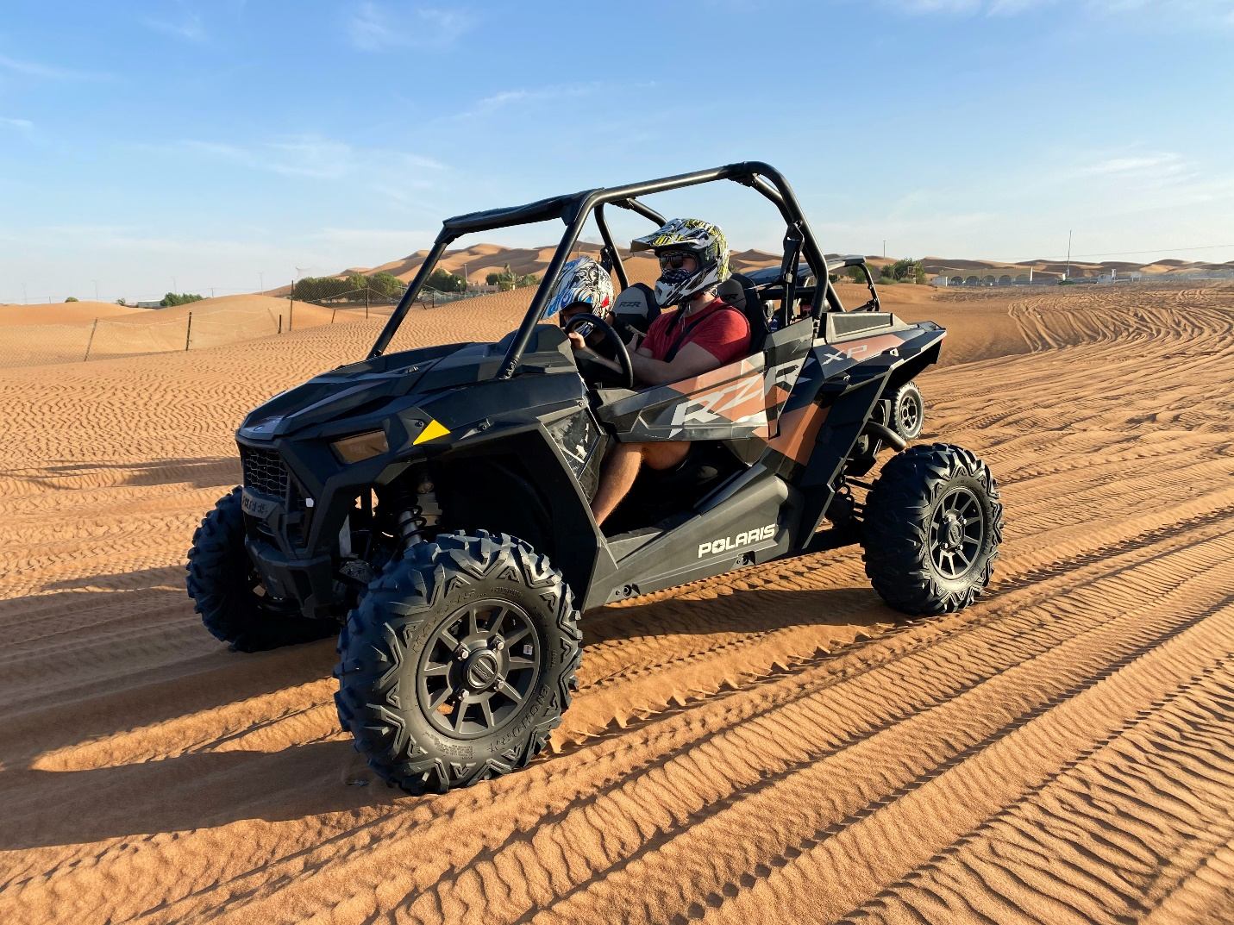

- Motorcycle - Most young adults start with two wheels, which is the cheapest form of street-legal transport. Great in the summer months, riding a 650cc sports tourer is not an experience you’ll forget in a hurry, which is why you see so many big bikes in the summer months. Of course, you need to have the right licence to ride a big bike (Class A), but you can start with a 125cc street legal bike and within a couple of years, you can obtain that Class A licence and climb aboard a 1000cc superbike! Downsides of motorcycles include the fact that it is more dangerous than riding in a car, as you don’t have chassis protection.

- Quad - If you are looking for transportation, you can buy quad bikes online from a reputable dealer. You’ll find a street-legal machine and get to choose from new and used vehicles of all sizes. If, on the other hand, you are only interested in riding your quad off-road at private venues, you can buy an off-road machine, which does not have to be taxed and insured, as it will not be travelling on public roads. Attach a trailer to the car, and you’re good to go! You can enjoy the many quad riding venues that are located on private land, and you can ride a street-legal quad to the off-road venue. The only downside to quads is the freezing winter weather, which also applies to bikes; most people garage their bike or quad until April or May.

Driving Licence Requirements

If you are going to ride a motorcycle on public roads, the type of licence you need depends on the size of the bike; a 125cc bike can be ridden with a provisional licence or a full car driving licence.

Here is a list:

- Class AM Licence - Minimum age 16, holder must take the CST test and pass the practical section, then you can ride a moped. A 16-year-old can ride a small quad with this licence.

- Class A1 Licence - The holder can ride a lightweight motorcycle with an engine capacity not exceeding 125cc. Must sit the CST test and pass the practical test. The minimum age is 17 years.

- Class A2 Licence - The holder can ride a motorcycle with a power output of no more than 35kW, and you can access this licence directly or progressively.

- Class A Licence - This allows you unrestricted access to all bikes and quads. You must be at least 24 to access this licence directly - the progressive route requires a minimum of 2 years holding the Class A2 licence.

Recreational Quad Riding

This is a fast-growing sector, which is reflected by the number of quad-riding venues popping up - places where you can trailer your quad and ride on their trails. If you don’t own a quad, you can rent one and you don’t need a driving licence. Simply sign a disclaimer, and you’re good to go!

