<h1>Rubbish Removal vs Skip Hire in London – Which one is best?</h1>

Everybody has to deal with rubbish; whether in residential, construction, or commercial buildings, eventually it has to be removed so a clean living and working environment can be maintained. When rubbish is allowed to pile up, that can become a problem for businesses and households. Sometimes, out dumpsters or wheelie bins are not quite sufficient when it comes to dispose excess trash.
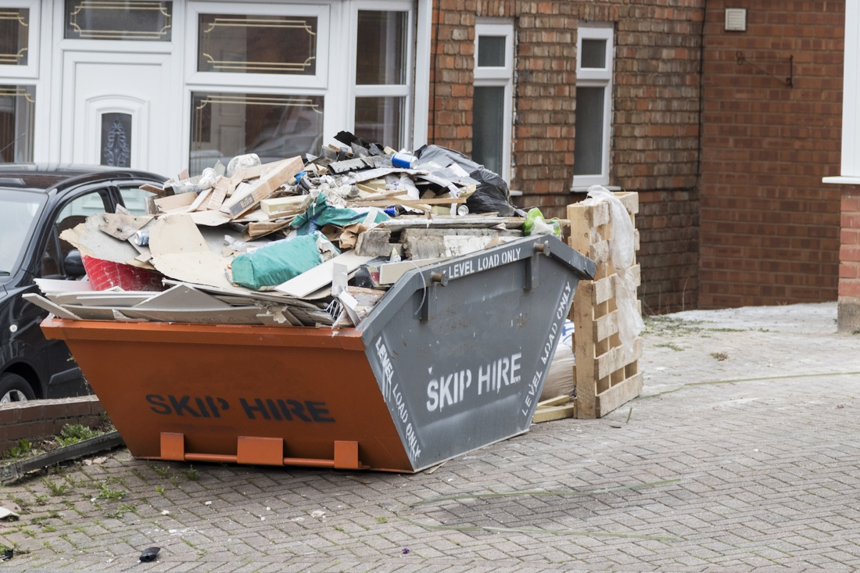
There are many options such as taking it to a waste disposal centre personally, gradually disposing of it over time, or as some people do, sneaking things into the bins of the neighbours. These options require a lot of work. The most effective option will be to hire a rubbish removal company or a skip. Deciding between rubbish removal services and skip bins is not always easy, but knowing the difference between the two services will help you make up your mind.

<h2>What is rubbish removal?</h2>

Rubbish removal takes care of unwanted debris from households, construction sites or working environments. They remove any amount of waste at a fast, efficient and affordable rate, and with little interruption to your personal activities. You can decide to hire a rubbish clearance service just once to take care of that pesky old furniture, or arrange for regular visits so your home or working environment will constantly remain clean. Rubbish removal services have a cleaning approach which is sustainable, and can clean all types of rubbish, while considering the environment.

<h2>What are skips?</h2>

They are big metal containers, usually ranging in sizes of 2-yard to 40-yard skips, used for storing rubbish until the bin is taken away for disposal. With skip hires, all the work falls on your shoulders – you have to do all the sorting, carrying and loading of rubbish.

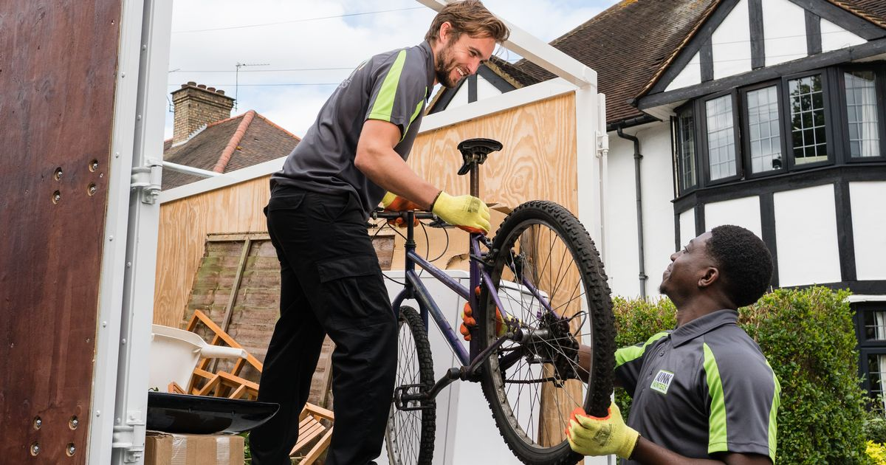
<h2>Rubbish Removal vs Skip Hire in London – Which one is best?</h2>

Hiring a skip bin can be quite expensive, so it is advisable to weigh all the pros and cons, and consider better options such as a rubbish removal company. You should hire a rubbish removal instead of a skip because of the following reasons:
- Even though a skip is kept at your residence for you to dispose of rubbish yourself, in London many people are not aware of the £30 skip permit they’ll have to pay for leaving it outside.
- While hiring a skip, it is not easy determining the amount of waste a skip can contain, you will be required to pay for the whole skip, even when you don’t use up all the space. But rubbish removal services only charge for the waste removed.
- While using a skip hire, you’ll be required to do most of the work of collecting and compiling all the waste that needs to be removed, and take it to the skip. This can be tedious, particularly for the sick or aged. But with a rubbish removal company, you can sit back and they’ll do all the collection themselves.
- While using a skip, sometimes your neighbour can fill in your skip with their waste, without you noticing, with is not ideal.
- Rubbish clearance companies have experienced professionals that have been trained in waste removal for various situations; they can access a waste situation and give an estimate that will suit your particular needs.

<h2>Why hire a rubbish removal service like Junk Hunters?</h2>
By using Junk Hunters, you’ll be provided with a team of two people to efficiently and promptly clear your waste, so all clearing process will be free of any hassle, without you having to put up with seeing a skip outside for many days.

Also, according to the founder, Harsha Rathnayake, you’ll get services that offer true value for your money when you use Junk Hunters as compared to hiring a skip. Their waste removal services are exceptional and have competitive rates against skin bins. In addition to taking care of residential wastes, they also collect commercial, garden, and office wastes.

Generally, rubbish clearing companies deal with wastes in the backyards like green wastes through to general cleanups. One major advantage is that you pay for exactly what you use, without getting involved in the process. Before deciding which to go with, ask yourself this question: How much work are you willing to put in? With a skip bin, the majority of the work is your responsibility, but with a rubbish removal service, the waste is disposed for you.

In addition to that, you should consider the kind of rubbish you are producing because skip hires don’t accept all types of wastes, and this could require you to make extra trips to dispose certain things. A rubbish disposal company like Junk Hunters collects most types of wastes.

